Tastehub Food App
Name: Virginia Munyori
Admission Number: BIT/2025/67506
Unit Code: BIT4107
Unit Name: Mobile Applications Development
TasteHub is a Flutter-based food mobile application designed to allow users to browse food items, add products to a cart, place orders, and manage their order history. The application demonstrates mobile UI design, navigation, API network handling and SQLite database CRUD operations.
Objectives:
• Create a user-friendly food ordering interface.
• Implement Flutter navigation between screens.
• Manage cart items and calculate totals.
• Store and manage orders using SQLite.
• Demonstrate API error handling and network status messages.
Technologies:
• Flutter and Dart programming language
• Android Emulator for testing
• SQLite database for local data storage
• HTTP package for API communication
• Android Studio development environment
Screens:
The application contains the following screens:
1. Login Screen - Allows users to enter email and password.
2. Sign Up Screen - Allows creation of a new account.
3. Home Screen - Displays food categories and available meals.
4. Cart Screen - Shows selected food items, quantities, and total price.
5. Checkout Screen - Displays order summary before payment.
6. Orders Screen - Displays saved orders from SQLite.
7. Order Details Screen - Shows individual order information.
8. Navigation Drawer - Provides access to app sections.
Database Implementation:
SQLite is used to store order information. The app supports CRUD operations:
Create - Saves new orders from the cart.
Read - Retrieves saved orders.
Update - Changes order quantities.
Delete - Removes orders.
API Networking and Error handling:
The application includes API service handling using HTTP requests.

Screenshots
Login Screen
User login interface
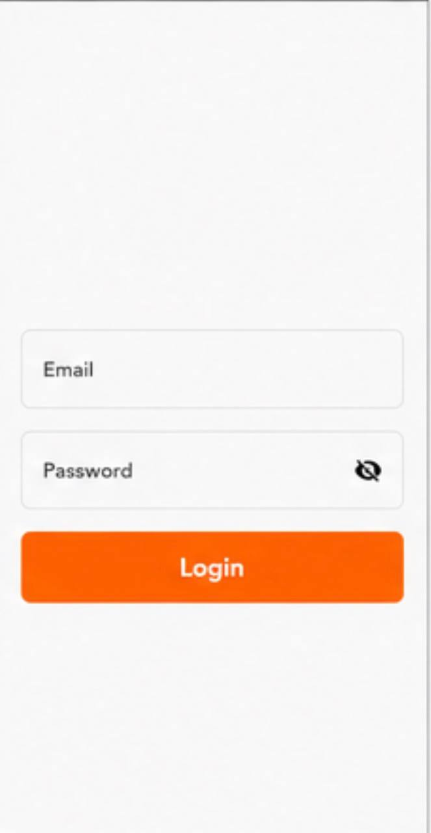

Sign Up Screen
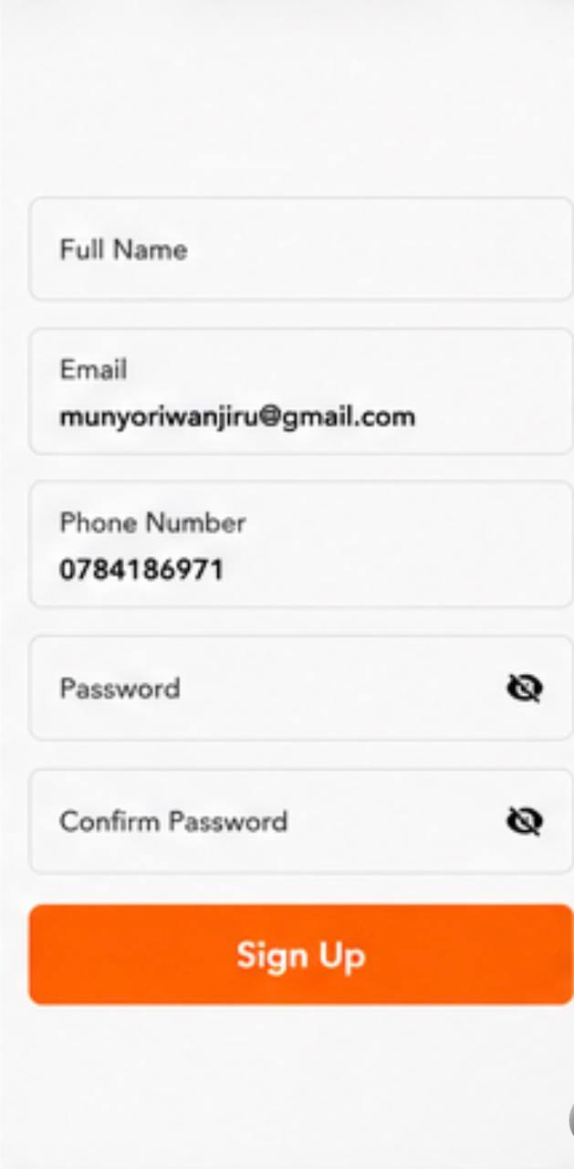
Enter your details

Home Screen
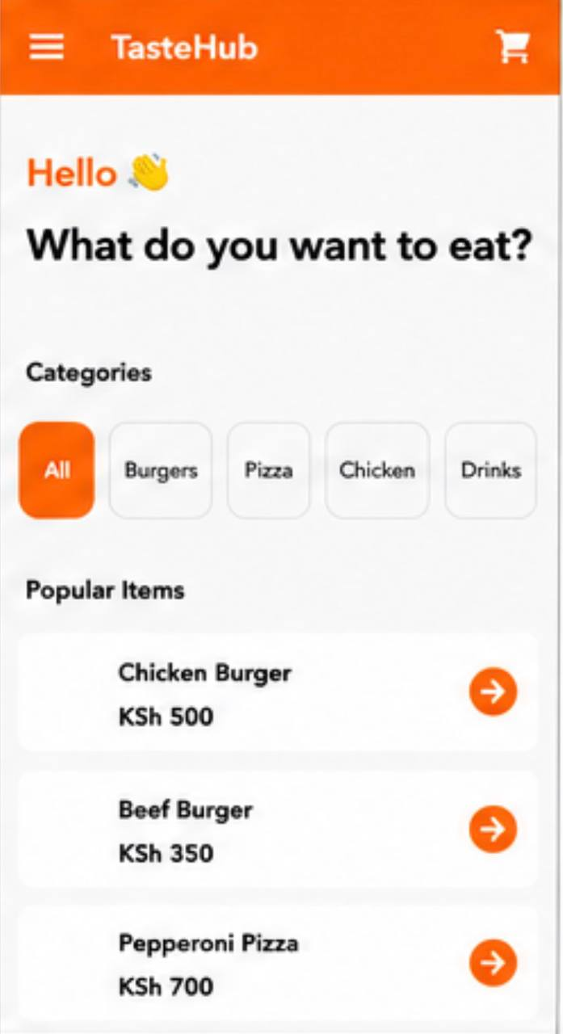
List of foods

Cart Screen
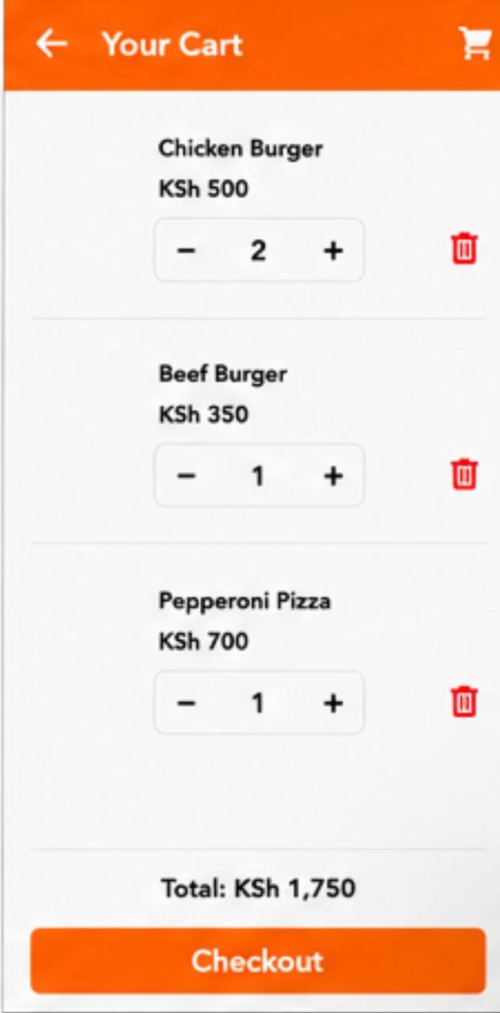
Food catalogue and add to cart

Checkout Screen
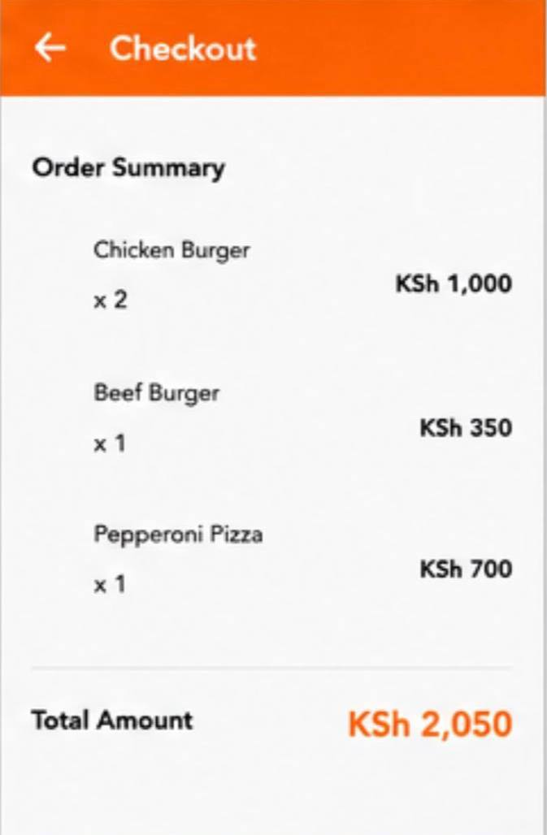
Selected items and total calculation

Orders Screen
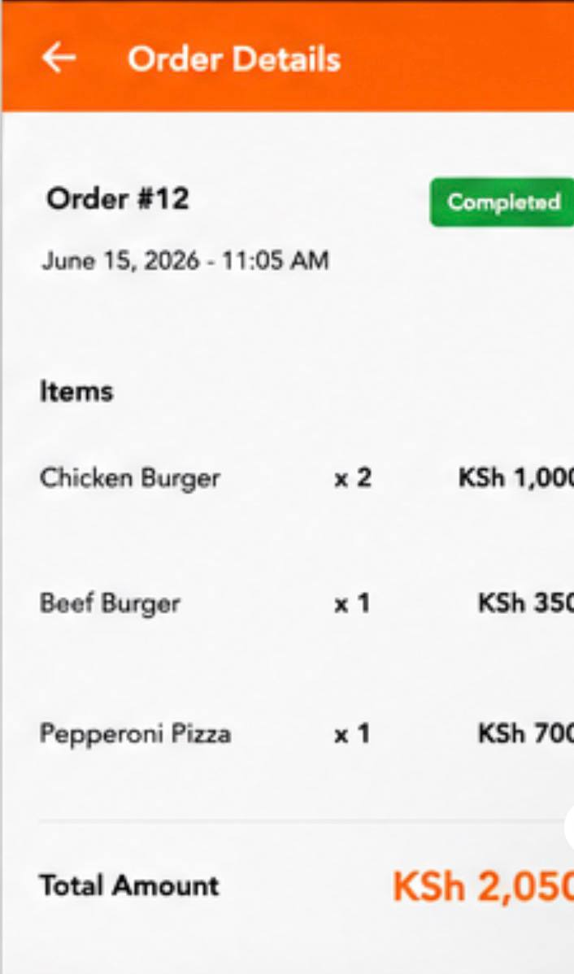
Payment confirmation process

Navigation
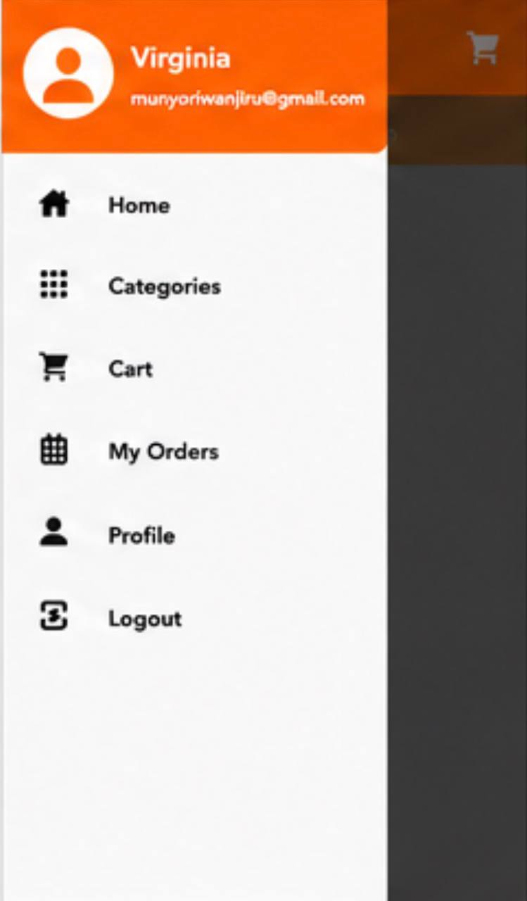
Navigate from one screen to another

Orders Screen
SQLite stored orders and CRUD operations


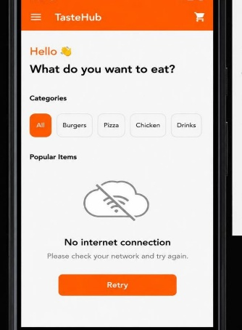

API Networking: Displays error message when there’s no network

Challenges Encountered and Solutions
Problems solved:
- Flutter running from the wrong project folder.
- Emulator showing cached old version.
- DatabaseHelper singleton errors.
- Cart model and Order model conflicts.
- Quantity update issues.
Solutions:
- Run Flutter commands from folder containing pubspec.yaml.
- Use flutter clean and rebuild.
- Separate CartItem and Order models.
- Use DatabaseHelper.instance singleton pattern.
Conclusion
TasteHub successfully demonstrates a complete Flutter food delivery workflow with navigation, cart management and SQLite CRUD operations

FoodHub Project LogBook
Week 4, 5, 6
Planning:
Planned the TasteHub food application, identified requirements and defined the main features including authentication, food browsing, cart, checkout and order management.
Interface Design:
Designed the Flutter application screens including splash screen, login, signup, home, cart, checkout, M-Pesa, orders, profile and navigation drawer.
Flutter:
Created the Flutter project structure, connected screens using routes, created food and order models and implemented the user interface.
Cart System:
Implemented cart functionality including adding food items, updating quantities, removing items, and calculating the total price.
SQL:
Integrated SQLite database and implemented CRUD operations for orders: Create, Read, Update and Delete.
Checkout:
Developed checkout flow and order summary
API Networking and Error Handling:
Tested application navigation, database operations, UI updates, and fixed Flutter build and emulator issues.
Final Documentation:
Prepared project screenshots, documentation and final improvements for submission.
Description:
TasteHub is a Flutter food application that allows users to browse meals, manage a shopping cart, checkout orders and store order records using SQLite.

Technologies Used:
- Flutter
- Dart
- SQLite
- HTTP API
- Android Emulator
- Android Studio

